Backline Attack: Trailing
Skill:
Trailing
Drill:
2 defenders vs. 3 Attackers & trailer (&SH).
X Y 1 2 & 3 + T

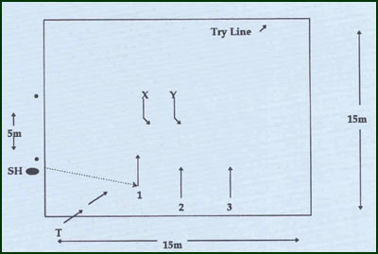
Key Factors:
- Play on-top of the defenders.
- Attack the space inside the defenders.
- Aim to put 3rd attacker away.
Over load:
- Larger grid- gives attack more advantage.
- Introduce 3rd defender at depth i.e. 5m back.
Groups:
Minimum of 7 players.

