Backline Attack
Skill:
Trailing
Drill:

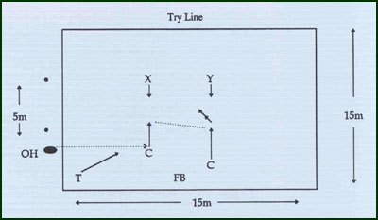
Key Factors:
- Inside Center holds/checks his opposite number BSW trails him.
- Outside Center is trailed by FB.
- Attacking the space inside of opponent.
- Trailing on the inside at depth.
Variations:
- Attacking line & defending line can run around cones before ball is delivered (re-alignment).

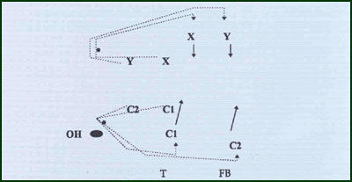
Groups:
Minimum of 7 players.

