Backline Play (Sub-Unit)
Skill:
Decision making by OH & communication/support
Set up:
Attacking players (SH, OH, C1, C2, & BSW)
Defending players 3 (Flanker, OH, C1)
When ball is passed defenders try to cover attackers by man on or drift/slide defense. Outhalf must read development with support of centres & BSW (alternate direction of attack).
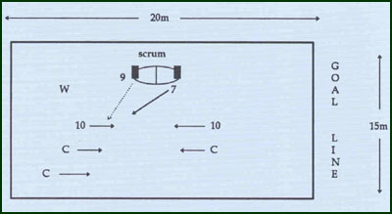
Key Factors:
· Proper alignment (for skill level and conditions).
· Straight running and proper lines of support.
· Sympathetic passing.
· Clear communication.
· Correct decision making.
Side step inside when attacking.
Options:
· Defence: - Man-on: use overlap or free player if :
- Early drift before OH passes: use BSW inside or outside.
- Late drift : attack space.
Generally:
BSW trails OH & C1.
Groups:
Minimum of 8 players

