Individual Attack: Trailing
Skill:
Trailing
Drill:
1 v 1 & trailer. One defender against an attacker & trailer (run around).
Attacker & defender run outside the marker; trailer runs inside the marker.
Trailer waits 2 sec. Before leaving.

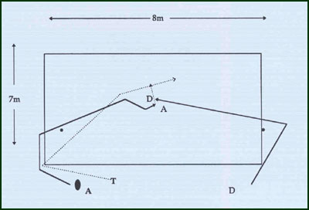
Key Factors:
- Attacker (ball carrier) must concentrate on attacking the defender on his inside.
- Trailer must support at depth on the inside of the ball carrier & judge his pace so as not to over-run the ball carrier.
Over load:
- Wider grid- more difficult for defender i.e. lateral movement!
- Narrower grid – more difficult for ball carrier i.e. more driving attack!
Groups:
Minimum of 3 players.

