Individual Positional Skill
Topic:
Individual (Positional Skill)
Skill:
Standing spin- pass (from hands)
Drill:
Player “ A” receives lobbed ball from “B” & returns it with a spin pass, simultaneously “B” tosses 2nd ball while “A” catches 1st ball & repeat. [Can also be done with 2 players serving the balls to “A” i.e. B, D, E, with A passing back to the source]. (Work for 1 min).

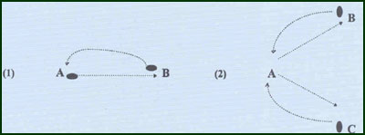
Key Factors:
- Quick feet “Skipping” into position.
- Wrist flick.
- Peripheral vision.
Variations:
- Overload:
-Reduce time for pass by lobbing the ball back at a lower trajectory.
-Increase distance of pass from 6m to 8m to 10m to 12m.
-Introduce 3rd ball or feeder!

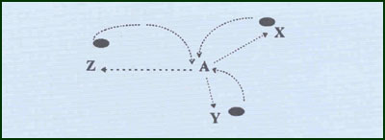
Groups:
Minimum of 2 players / 3 markers.

