Individual Skill (Backline unit)
Skill:
Reaction & Lateral Passing.
Set up:
4 players aligned as a backline (each has a number) 1st player i.e. ball carrier no. 1 etc. Ball carrier, when he reaches a marker must pass the ball to the number called out/indicated by the coach. Coach stands approx. middle of the grid. Ball is passed onto last man who re-aligns to repeat drill in the other direction.

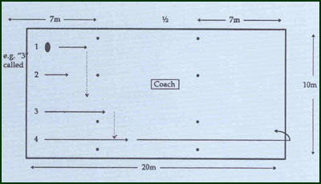
Key Factors:
- Keep ball carried on the inside.
- Run straight, change of pace when receiving a pass.
Development:
- Have a SH pass the ball to the 1st player.
- Overload by coach calling/indicating later i.e. when ball carrier nearly reaches marker (7m).
- Receivers call their own numbers, last number called before ball carrier reaches cone in the target!
Groups:
Minimum of 4 players; ideally 5 & a coach.
Assessment:
· Another marker can be placed at 5m for a signal, pass to be made by 7m. Count successful executions out of 10 attempts.

