Individual Skill: Agility and tackling
Skill:
Agility & Tackling.
Drill:
Player ‘A’ sprints to cone on signal “GO”. Before reaching the cone he will receive a signal “LEFT” or “RIGHT”. ‘A’ then takes over bag & releases player to join queue. OR
Use 2 players – ‘A’ hits designated bag, ‘B’ hits other bag.
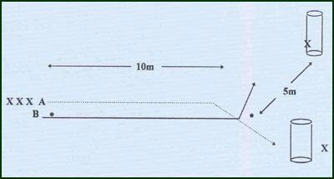
Key Factors:
· Low body position.
· Short, quick strides with quick arms.
· Drive with legs & grab tightly with both arms.
Variations:
· Use rucking pads instead of tackle bags – Hit & Drive.
· Overload by delaying instructions as close to cone as possible.
(markers can be placed 1 meter apart from the last cone backwards for 5m!)
Groups:
Minimum of 3 players.

