Individual Skill: Changing angles
Skill:
Changing angles when receiving a pass.
Set up:
Player “A” carries ball forward, “B” calls for (long or short) ball & negotiates obstacle, & then passes to “C” who links up with next group.

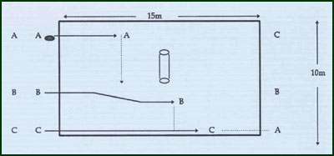
Key Factors:
- Clear communications.
- Appropriate pass (short pop or long).
- Change of running lines (late as possible).
- Good lines of support by “C” to receive pass.
Development:
Groups of 4/5 & using 2 bags staggered.

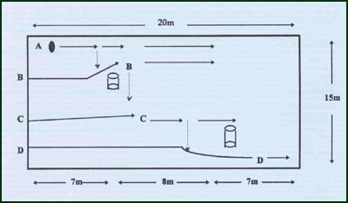
Groups:
Minimum of 3 players; Development 4/5 minimum.

