: Individual Skill: Circle passing
Skill:
Circle passing
Drill:
Player “B” runs & passes to A after 3-5m. Player “A” (ball carrier) runs forward & side steps off right foot & circle passes to “B” who receives the ball & continues until he delivers to “C” (repeat) [“C” side steps off left foot on the ay back!]
Opposition:
Introduce “grab tackle” defender Z.

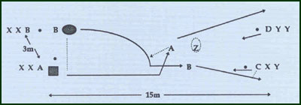
Key Factors:
- Carry ball in two hands.
- Side step sharply & establish a base.
- Float ball into path 7 inside ball.
- Trailer support at depth & inside ball carrier.
(Change angle only after ball carrier)
Groups:
Minimum of 2 players.
Variations:
· Build up line of players e.g. 4 (any of which can side step).
· Introduce 3rd defender at depth i.e. 5m back.

