Individual Skill: Evasive Running
Skill:
Evasive running & decision making.
Set up:
Area approx. 30 long & 10 wide. 2 defenders & 2 attackers (with feeder if possible).
Player A receives pass while running from feeder, and is marked by defender 1. Player B supports A and is marked by defender 2.
Defender 2 begins approx. 5m-10m back from player B, while defender 1 begins 20-25m back from player A.

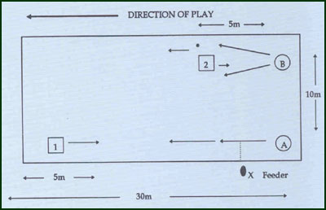
Key Factors:
- Ball carrier a tries to beat defender 1 or at most remove him from a space for player B to move into - i.e. evasive running (angles & pace).
Player B runs around defender 2 (speed) or cuts inside him to receive a pass from a –i.e. (angle change).
Over load:
- Bring the 2 defenders closer i.e. defender 1 moves up closer to attackers.
- Reduce width and length of area.
- Defender 2 not conditioned to just attacker B

