Individual Skill: Grubber & chase
Skill:
Beating opponent with grubber (or chip) & chase.
Set-up:
Player ‘A’ attacks with the ball, ‘B’ defends (grab). Players start back to back. [corner of 15m square grid]. Attacker may grubber, chip or dummy to score. Both players must first run around designated markers 8m away.
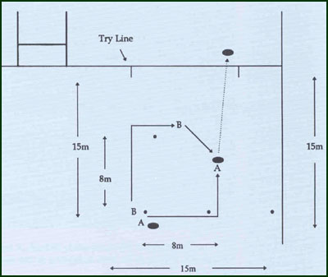
Key Factors:
· Defenders should observe attacker while running around in order to judge pace correctly.
· Don’t over-commit as defender.
· Use touchline as extra defender.
· Make defenders over-commit or under-commit.
· Ball carry in correct hand.

