: Individual Skill: Lateral passing
Skill:
Lateral passing/spin passing (assessment)
Set up:
Player “A” runs 10 times up and down a grid receiving & passing once on each length (receiving from “X” and passing to “Y” staggered 2m apart.

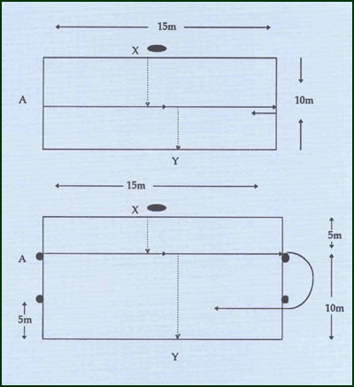
Assessment:
Every bad pass adds 3 seconds to total time to complete 10 lengths.

Overload:
(A) 2 players working as a team.
(B) Player must pass to target 15m & 20m away.
Groups:
Minimum of 3 players

