Individual Skill: Peripheral vision
Skill:
Peripheral vision
Set up:
2 feeders A & B, 1 player working (X) & using 2 balls.

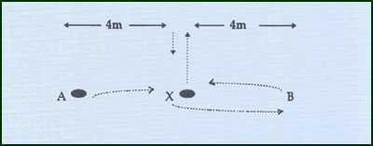
“X” throws ball up, “A” passes 2nd ball to X who catches & passes to B, X then catches original ball & throws it up again, while B passes the 2nd ball back to X who passes it on to A & then catches original ball again –(repeat 1 min.).
Key Factors:
- Correct toss up by X, using peripheral vision sight incoming pass from A & distribute to B, while still keeping “half an eye” on original ball.
.
Assessment:
- Count the number of successful passes i.e. A to X to B while still catching original ball.

Overload:
Increase number of players in the drill (e.g. 2 players X & Y attempt to throw, receive, pass and catch side by side.
