Individual Skill: Reaction, agility, tackling
Skill:
Reaction, agility, tackling
Drill:
Player ‘A’ on ‘B’s signal (right or left) runs to appropriate cone and then accelerates into tackle bag. ‘A’ then holds tackle bag while ‘B’ joins back of line (repeat).
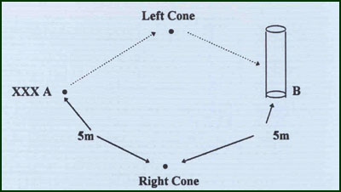
Key Factors:
· Short, quick strides.
· Quick arm movements.
· Low body position.
· Drive with legs, grab tight with arms.
· Get up quickly.
Variations:
· Work 2 groups & 2 bags with 1 signal.. Have a race!
(diagram required)
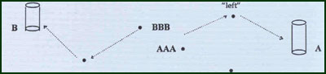
Groups:
Minimum of 2 players.

