Individual Skill: Switch
Skill:
Switch (decision making)
Drill:
“X” defends “A” initially. “A” attacks “X” using a switch (or dummy) with “B”.

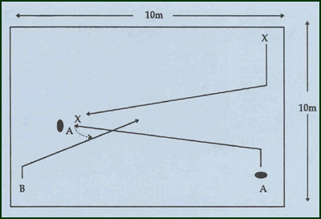
Key Factors:
- Sharp change of angle and pace by ball carrier.
- Keep ball shielded from defender.
- Pull defender as far across as possible to create space for “B”.
- Support player “B” should wait until defender is drawn out of space before occupying it.
- Clear communication by support player.
- Correct decision to pass or dummy.
Groups:
Minimum of 3 players.

