Individual Skill: Tackling & Controlling
Skill:
Tackling & controlling the ball in tackle, defender winning
Drill:
Player “ A” tackles player “B” (ball carrier). Player “B” controls the ball & places it correctly. Player “X” picks up the ball (approaching from the opposite corner) & continues to player “C” [who repeats]. Player “B” (initial ball carrier) remains as next tackler. Original tackler “A” continues on [i.e. A join Y].

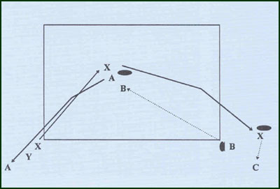
Key Factors:
- Tackler (usual).
- Ball carrier (usual).
- Picking up –defender approaches side-on, steps in behind the tackled ball carrier & picks up ball.
Variation:
- Ball carrier evasion (intensity).
Groups:
Minimum of 5 players.

