Individual Skill: Tackling and regaining
Skill:
Tackling and Regaining the ball
Drill:
Player ‘A’ tackles player ‘B’ carrying the ball. Player ‘A’ gets to his feet and picks up the ball. Player ‘A’ delivers the ball to player ‘C’. Player ‘B’ tackles player ‘C’ contd.…
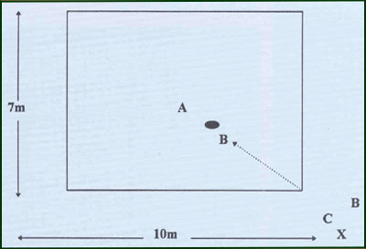
Key Factors:
· Tackles – low body position, angles, head, arm, drive, etc.
· Ball carrier – 2 hands, exchange to 1, wide base, ball placed last with proper hand.
· Picking up – wide base, bent knees, 2 hands.
Variations:
· Ball carriers align from one corner.
· Ball carriers may evade.
· Tackler must run around a marker.
Groups:
No greater than 6 players.

