Mini Unit
Skill:
Counter Attack (from kick)
Set-up:
Player X kicks to receivers A, B & C, while players Y & Z chase the kick followed by X. Players A, B & C counter attack, first beating players Y & Z and finally X. Rotate attackers and defenders and repeat.
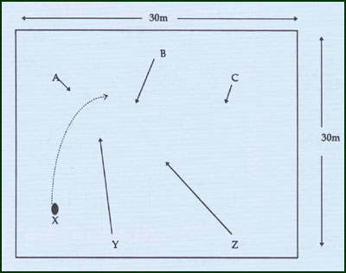
Key Factors:
· Early decision and communication that counter attack is possible.
· Feint at opposition strength (of numbers), while attacking weakness (space).
· Support must have adequate depth, width and timing.
Groups:
Minimum of 6 playerss.

