Positional Skill Assessments
Skill:
SH pass (one side).
Drill:
Player ‘A’ working, players X & Y feeding balls. X & Y stand facing the same direction & slightly staggered (preferably facing each other).
Player ‘A’ receives ball from X & passes to Y, then he runs around the back of Y to receive the ball facing Y, which he passes to X (repeat – 1 min drill).
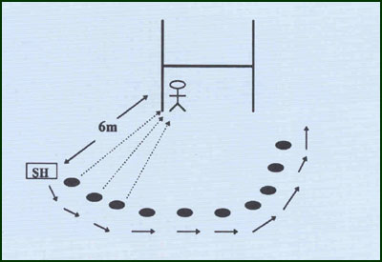
Key Factors:
· Narrow base (quick feet), ‘skip in’ if possible.
· Wrist pass, momentum and follow pass.
· “Trap” a moving ball with “lead” hand.
Variations:
· ‘X’ & ‘Y’ deliver ball in the hands & on the ground.
Overload:
· Increase distance 8m to 10m to 12m to 14m.
· Awkward delivery of ball.
Groups:
Minimum of 3 players.

