Specialist Skill Assessment
Skill:
Hooking (striking the ball)
Set up:
(1) Player props up against goal post/scrummaging machine.
(2) Place 4 yellow markers (2ft x 1ft rectangle) where the LH prop’s shoulders would be.
(3) Place 2 red markers where channel 1 would be i.e. between Flanker & LHS 2nd row.
(4) Place 2 white markers where LHS 2nd rows feet would be i.e. channel 2.
(5) Place 2 blue markers where RHS Locks feet would be i.e. channel 3.

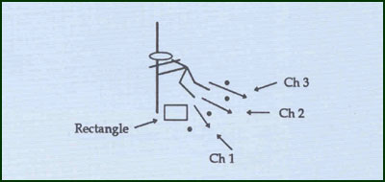
(6) A ball is placed in the rectangle & the Hooker must strike the ball through the designated channel (10 balls; 4 to Ch. 1; 3 to Ch. 3) assess correct /good strikes out of each channel.
Key Factors:
- Good flexibility
- Sweep with back of heel rather than jab.
Progression:
- Balls are fed into the rectangle on the Hookers signal – count successful strikes.
Groups:
Minimum of 1 or 2 players.

NB*
Use 3rd party as a LHP if available.

