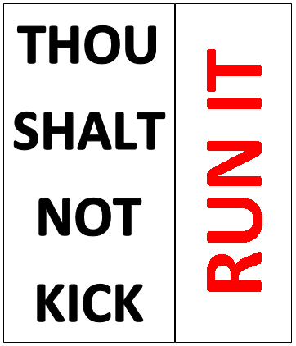

Rugby Basics

Object of the game:

Have fun and score tries!
Basic principle of the game:

Run at spaces, not faces!

The Ten Commandments of Bishops Rugby:
- Position quickly and Position Purposefully.
- Move as the scrumhalf touches the ball.
- Pass sympathetically to suit the situation.
- Pass and support (in that order).
- Primary support the receiver.
- Don’t risk ball security for insignificant yardage.
- Look for and create space not contact.
- When outside a teammate caught in possession - stay there.
- Run angles that create an advantage.
- Vary the type and point of attack.

https://blog.pitchero.com/5-experts-tips-for-attacking-in-rugby

Attack
To win games of rugby, you need to score more points than the opposition. The best way to do that is by securing as many tries as possible during the 80 minutes.
Whilst this may be over-simplifying the game a little, adopting a bold, attack-minded strategy will translate to more victories on the field.

Basic cut plays - Conrad Smith
Used at all levels of the game, the cut play is one of the games simplest attacking moves. Devasting when executed well, New Zealand great Conrad Smith has executed a few inch-perfect cut plays during his career.
To initiative the cut play, the first receiver has to engage the opposition defender, dragging them across and creating a gap in the defence.
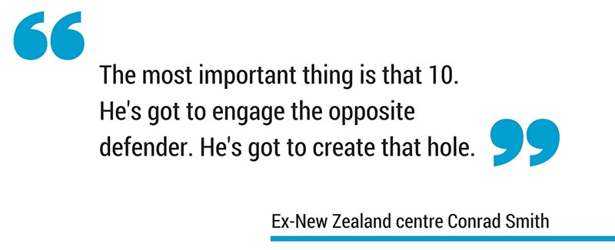
The cutter, be it a 12,13 or winger, then needs to run at pace through the space created. For them, it's vital to run as straight as possible. That way, they can stay in touch with their fellow backs, remaining on the same side of the field where they can provide support.

Attack off 10 - Eddie Jones
When building an attack off your 10, the fly-half needs one thing – options. England coach Eddie Jones wants his teams to create a triangle of options that the ball receiver can hit in order to begin an attack.
Ideally, that triangle would be made up of an inside and outside runner (i.e. your best ball-carrying back rowers), plus the 12 hanging back a little.
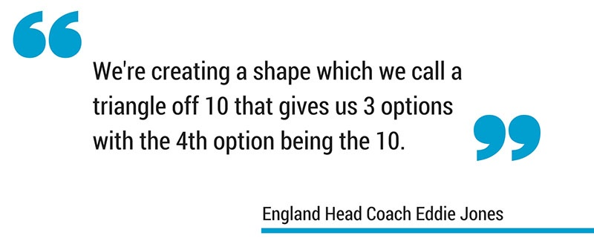
Throughout, players need to be watching defender's shoulders for weak spots. If it's clear which direction the defender is intending to move, the attacker can make the hit on their weaker shoulder.

Offload and continuity - Gregor Townsend
For Scotland's soon-to-be-head-coach Gregor Townsend, avoiding the breakdown is a valuable facet of the game that is often ignored.
To do that, teams need to exploit space and ensure continuity and pace in their play. Keep the ball alive as long as possible and avoid the potential pitfalls of the breakdown.
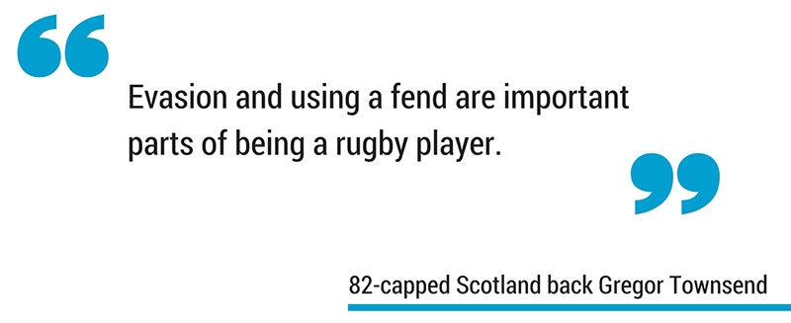
Every player should be aware of the space around opposition defenders. In 1-v-1 situations, exploit it to open up off-load opportunities and keep your team's momentum going forward.

Counter attack Wayne Smith
Good counter attacks are based on what the opposition's chasing defence is doing. As a result, one well-executed counter can look very different to the next. What's important is recognising what your opposition are intending and knowing how best to exploit them.
First off, look for space in which to base your attack. If you don't have it, create it by dragging opposition defenders or kicking.
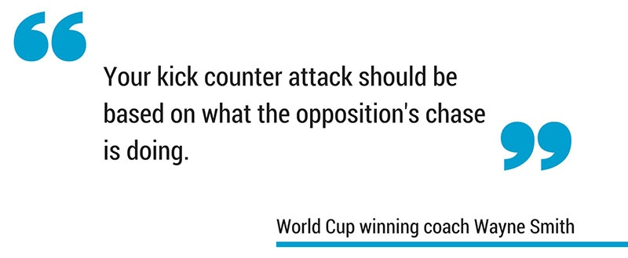
In the face of a spread defence, identifying and exploiting mismatches are vital. Look for opportunities for your speedy backs to run at less agile defenders- even if it isn't on the first phase.

Side step - Shane Williams
For fleet footed wingers and full-backs, you need a weapon to unleash in those 1-on-1 scenarios. The side-step offers that with devastating efficiency – with no better example coming from Wales legend Shane Williams.
His tips on beating defenders one-on-one starts with running at an angle rather than straight on. Dragging the defender in one direction, the aim of the attacker is to change momentum at the last minute, leaving your opponent flat-footed.
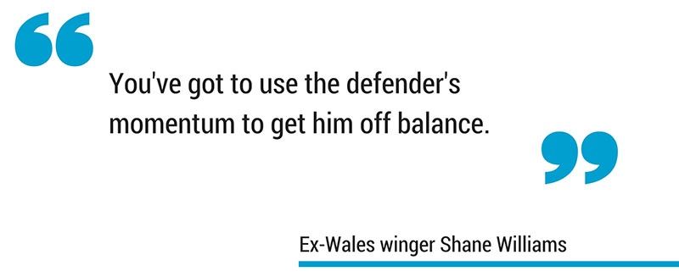
Commit defenders to one side as much as you possibly can. Even if you don't beat the defender entirely, your step will keep the tackle low – freeing up your hands for an offload to supporting players.

https://www.alloutrugby.com/how-all-blacks-blanked-bok-attack/

2. Defence
Oom Rugby
Well, I do not want to beat our boys with a stick. There is enough of that now. But I am interested in some of the technical reasons why the Boks did not often manage to get nice, quick ball on Saturday. Without quick ball even, the best backline in the world is a lost cause because the defence is in control.
The first reason of course is that our set piece was a nightmare not like anything we have seen in the modern era. Set piece is the foundation of creating quick ball, because the forwards are out the equation and there is space. But apart from that, the first interesting thing I notice in the example below is a tactic the All Blacks used time and again on our big carries…
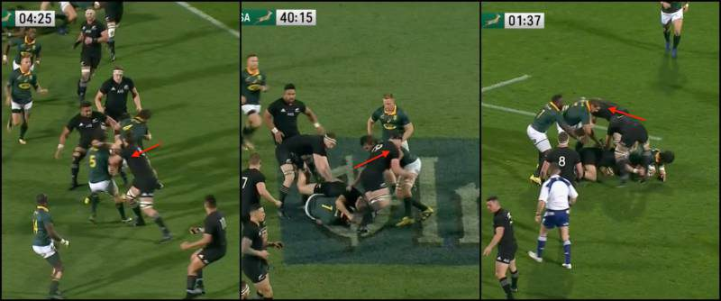
These carries are meant to generate momentum and get us playing on front foot but look above at how the All Blacks take out the first Bok support player.
First picture, Eben carry but Whitelock focus on taking supporter Franco out of the equation. Second one Beast carry, and Crockett prevent Eben from sealing. Third is an All Black taking Dreyer out on his way to clean over Eben. These carries are very important to try and get the defence going backwards so that you can start to dictate, but the All Blacks very cleverly targets the support runners and then able to get over the ball and slow it down. Huge.
And it is kind of legal. Because modern pods carry right up to your face with a short pass at the last second, defence sometimes end up taking the extra pod men anyway in a “pre-empt” tackle. The All Blacks used this “pre-empt” tackle as disguise for taking out our support. The Boks will have to plan for this.
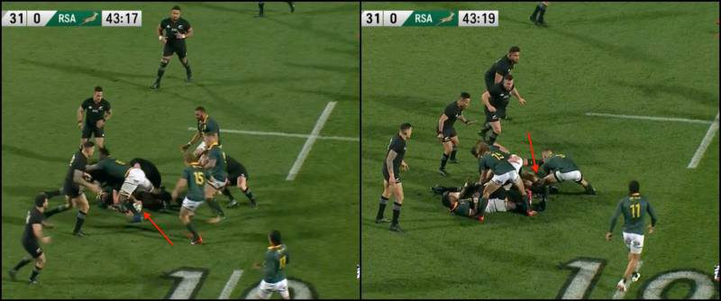
The next thing we see above was occasions when Boks slow own ball down through poor technique or messy focus. In this example we see the ball is presented after a carry by Marx. First thing is a very sloppy clean by Siya who just slide across the man and don’t stop Crockett from disrupting. Then Coles move the ball with his leg, before Uzair come flying in and it just become a tangle of legs over the ball.
With a good initial clean by our openside the ball could have been played at 43:17 but it is already 43:19 and the ball is not out yet. Look at how defence is set and ready to dictate.
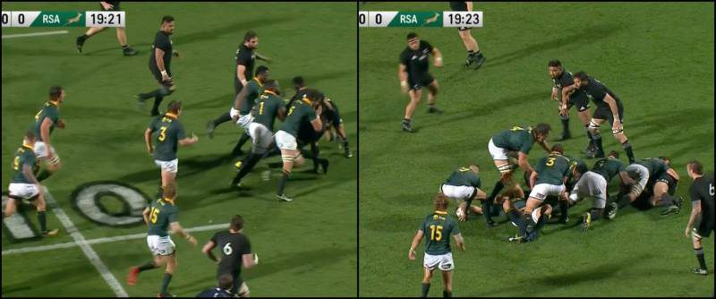
In the next picture above, we see another huge carry by Malcolm. Hell, this guy is special hey… His carries and steals absolutely terrorise the All Blacks. Just a pity about his lineout throwing!
Anyway, we see Franco, Beast and Siya in support and they blast over the ball. Then more troops arrive and Eben and Ruan also go and attend the ruck. Including Hougaard that is 7 Boks all out of play.
Rugby is a numbers game and at this level you cannot have almost half your team at one ruck. We can understand Bok frustration and wanting to clean the hell out of the spoilers at the ball, but cool and clinical heads must prevail.
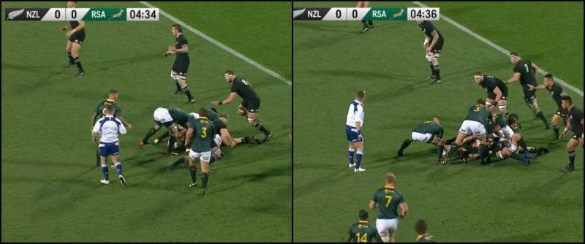
We spoke about quick ball and how it is holy grail of rugby. With quick ball we neutralise the speed of the defence, we can run at retreating and disorganised defenders, we run at static defenders, we can play at speed.
In the chain of quick ball, the scrumhalf is the sparkplug. If he is not firing, then all our hard work in the carry and at the ruck is for nothing. Remember guys, the difference between quick ball and slow ball can be one second. It is the time it takes for a defender to turn and be ready, or for him to be static or starting his sprint.
In today’s game with trend of rush defence we are dead if our ball is slow. In the picture above, we see the ball is presented but Hougaard is not there. He waits for Ruan to come and lie (unnecessarily) on the ruck before he passes the ball. In that time the All Blacks has folded an extra man to the far side and is nice and organised and ready for the Bok attack.
Another cause of lack of momentum is the Boks alignment and timing of their runs off 9… Many times, we see them catch the ball static and get caught deep. There many reasons for that so maybe that can be a story for another day!
Anyway guys, this was a freak game where absolutely everything go wrong and the score line reflect that. I am not saying Boks was going to win, but we do not often see so many things in a “perfect storm” like we did on Saturday.
Our boys must pick themselves up, remember that they are better than that, focus on simple technical execution, trust in each other and stay away from Twitter. Then they will be fine!
- Grant Dexter
September 20, 2017 at 9:43 am
I must admit that this column is the best bit of analytics I have heard from a South African viewpoint. These issues have been the same for several years now yet nobody in the Springbok set-up has either identified it or identified a solution to it. I vote for Oom Rugby to become Boks specialist consultant. We need someone who actually analyses defensive and attacking systems against us and then innovate our rugby. Just like New Zealand did after we owned them in 2009. Look what they have turned into! There is no reason South African rugby can’t do the same. Why are none of our SR and CC teams implementing the ideals they should have learnt at the various indabas? In theory, our SR and CC teams should be training like the Boks and playing at international pace thus dominating and being an exciting brand.

  - Geoff
September 20, 2017 at 10:35 pm
In 2009 those Bok victories had more to do with the experimental laws favouring defence over everything else. Hence the reason the Boks just kept kicking it away to the ABs and then earning the penalties because of the law variations.
the following year so those were removed, and the Boks haven’t adapted since.
- Oom Rugby
September 20, 2017 at 10:04 am
hey cheers Grant! but I am just a peanut gallery guy with benefit of hind-sight… Much more clever guys in rugby trust me!
- Chris Mouton
September 20, 2017 at 10:13 am
Good article, Oom Rugby.
The things you are talking about here are the basics.
I have learned them at school already:
– Stay low and clean well
– Don’t over-commit at the rucks
– Try to keep the ball alive with off-loads and pop-up passes
– Scrummie pass immediately without taking a few steps. Why? The ball is faster than the man.
– Track the inside hip with tackling
The things listed above are just a few basics drilled into us, and this was about 20 years ago! Shouldn’t our NATIONAL team have this figured out by now?
  - Oom Rugby
September 20, 2017 at 10:20 am
yes, Chris you are right. at that level we expect better technical execution, even in the high-pressure high-speed “cauldron” of Test rugby. basics…
- Wessel van Rensburg
September 20, 2017 at 10:33 am
Great analysis. But there are other issues looming now. The perfect storm wasn’t a fluke. The thing that really worries me Oom is the Bok team’s new psychology when playing the All Blacks. Seems to me they have gotten into our heads. When they produced two good tries after some decent plays from us we became indecisive, unsure, and made mistakes. They produced their best 40 minutes of the year, and we responded with our worst. The fix is half technical but otherwise it lies in the ‘spirit’.
  - Rikus Dercksen
September 21, 2017 at 2:42 pm
I believe that this is a leadership issue, not a captain, but a guy who has put his body on the line. And when he says let’s pull it together, he shows his team how. This is a good team, with good players, but we need an inspiring leader on the field. I hoped that Eben and Siya could do this, but they had a tough day.
    - Herrie
September 26, 2017 at 1:30 pm
I agree Rikus, Warren is sorely missed for his inspirational leadership.
  - Oom
September 20, 2017 at 1:11 pm
ja good point. many young guys deers in headlights.
- vaughn
September 20, 2017 at 12:05 pm
Our team is too busy spending time on the colour ratio and not on the game plan. Much more important.
Funny
Vaughn
- Lions Fan '82
September 20, 2017 at 1:25 pm
Great article, Thanks Oom! The Public have had lots to say about players that should be in the Bok squad, but there are some names that should be in the coaching staff. Oom Rugby should be there… beslis!! Oom Nic should also be there. ‘n Paar harde baarde!! Glad Rassie is coming back. Think he can fix a few things. It’s been the small technical things that cost us. Things we seemed to be doing well with up until Saturday. But that is Rassie’s strength, he eats that for breakfast. So, the long term problem has lots of hope on him as the solution, but for now what do we do?? It’s been very quiet from the bok camp on any call-ups or solutions being looked at going forward…. but that’s understandable, there’s lots of footage that needs to be analysed. When will we hear from them? The longer we don’t hear about a call-up, the more we must doubt a call-up at all. Surely, they’ll make that call as early as possible, I’d say latest today?
- Matt
September 20, 2017 at 1:55 pm
Oom, can you do an analysis of our tactical kicking please? I believe over the Aus and NZ tests it played a huge part in our opponent’s ability to control the game much better than us. Thanks!
- Fred.
September 21, 2017 at 10:50 am
The team spirit is non-existent in the team. How can it be with the quota system? When the opposition attack, there are only 13 defenders in the “Bok” team. Both wings are absolutely useless on defence, and hence the huge try scoring opportunities for the All Blacks. I’m sure the Aussies took note, and will no doubt run at the wings where the space opens up like a barn door.
- Greg Shark
September 22, 2017 at 10:28 am
Nice analysis. I’ve been whining quite a bit about Bok players taken out well off the ball at rucks, what is the take on that? Cleaning out players in support should only be those players attached to the ball carrier not running steps behind!
- max
September 22, 2017 at 2:07 pm
If we look at our coaching staff, we lack a defence coach. Allister Brendan and Franco are or were backline coaches and that’s what the Boks lacked on the day. there were no second line defence not even a single player and there was no urgency to fall back. The modern game is based on decoy running (but only one word for it obstruction). you look at the dummy runners in front of the flyhalf to outside centre and making contact and confusing the defence. The offside players that run across the field and towards the running player blocking the view and taking out the defence when the ball is kick and the wing passes the ball to attacking fullback. Around the ruck and malls where defence are taken out to create a gap to attack. and the list goes on. I’m starting to think the game plan is to manipulate and to blindside the officials. the evidence is on tape.
- Gerhard Coetzee
September 22, 2017 at 4:07 pm
This is a great article. You have highlighted that the set piece is a great opportunity to attack with space available, however our back line was not able to get the upper hand when it was man on man (where is another Danie Gerber, Pieter Henriks etc ,who could beat their man ).There is about 40 back line moves and we have to try some from set piece play. I thought in the first 10 – 15 minutes the forwards did well, and the back line had enough good ball, but could not score with a number of opportunities that did not result in tries due to over eagerness. Comments are closed.

THE TEN COMMANDMENTS OF RUGBY

1. Thou shalt not hesitate at the breakdown but be mighty to get your
rightful ball; for though it is written that the meek shall inherit the
earth, this is truly was a poor translation. The meek shall be trampled
into the dirt is more to the point.
2. Thou shalt not speak profanely of the Whistler, nor question the purity
of his birth, even though he be blind to transgressions by devils on the
other team at the ruck and the maul, and whistles them not.
3. Thou shalt not smite an opponent with a clenched fist, yeah, even in
retaliation; for it is written that the Whistler and the Flag Waver shall
assuredly miss the cowardly first punch, only to see the avenging second.
Believeth that what goeth around shall surely cometh, and verily, evil men
will be found at the bottom of rucks.
4. Thou should not kiss thy teammate on the mouth when he scores; for such
is an abomination unto God, especially kisses in tongues, unless you play
football with the round white ball and thus it is expected.
5. Thou shalt not take the Word of the Coach in vain, for blessed is the
Word of the Coach. Instead, wonder at his mighty wisdom and sticketh to His
Game Plan, lest the Coach acquaint you with his disciples
coaching in the lower grades.
6. Thou shalt not chip nor kick for touch if thou be a prop or wear any
jersey number below that of 7; for this is an abomination unto the Coach,
and surely you will be His at training, perhaps everlasting.
7. Thou shalt not run across the field with ball in hand, but runneth
straight ahead upfield; for it is written that the touchline is the best
defender.
8. Thou shalt not kick the ball to thine enemies unless it bounceth; for
the Spirit of the bounce of the Ball may cause confusion unto them, and if
thy heart be pure, make it bounceth back unto you.
9. Thou shalt not pass the ball to a teammate about to be smashed by the
mighty enemy, unless he owes you money, or has rodgered someone dear to
your heart, in which case all is forgiven.
10. Thou shalt not vomit on thy teammates after the game, for this is
unmanly, and they could do it unto you.

